Explaining Pup Inflation

Are good dogs getting better? That is the question David H. Montgomery set out to answer by analyzing the ratings of dogs tweeted out by @dog_rates from Jan. 1, 2016, to March 26, 2017. His conclusion? America’s good dogs became significantly better dogs over that year.

One analysis he didn’t do? He didn’t plot a line of best-fit. That is, given a plot of the data, if we drew a line threw the points that fit the data “best”, what would it look like? Doing this should give us an idea of what way the data is trending. A line sloping up? That suggests the rating have been increasing over time. A line going down? The opposite.

So I’ve done that for you.

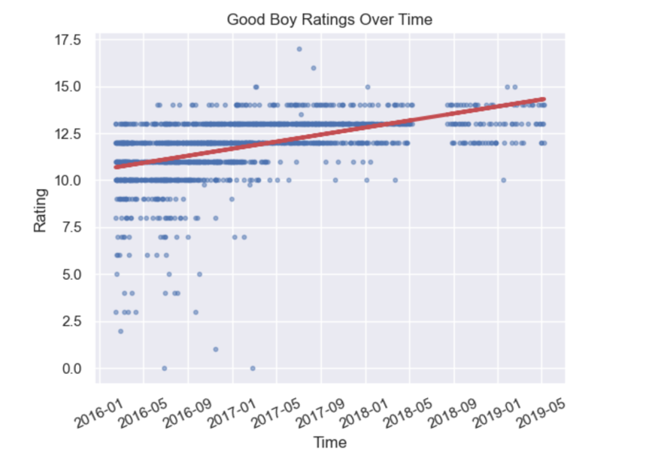

So, how are our good boys doing? Based on the upward slope of the red line, it looks like things are getting better over time. At the start of 2016, if we were to make a guess at what any given tweet were to rate a pup, we could do no better than guessing around 10.5. And as early as the start of 2018, that guess should have jumped to over 12.5!

But maybe we should be a bit careful with the red line. Take 2019-05 for example, the far right side of the graph. If we made a prediction for the average rating here, do we really want to be predicting around 14? How about by the end of 2019? Are all of the ratings going to be around 2019? It doesn’t really look like it, does it? So maybe something else is happening.

One guess: it looks to me like @dog_rates quit handing out low ratings. From the middle of 2017 onwards, the lowest rating handed out was a 10! So maybe what we’re seeing isn’t so much a gradual increase in the ratings, which would suggest that over time the ratings will just get higher and higher, but instead compression of the lower ratings (into higher ratings) which leads to a decrease in the variance of the ratings handed out? Hmm… How might we be able to see if that were the case?

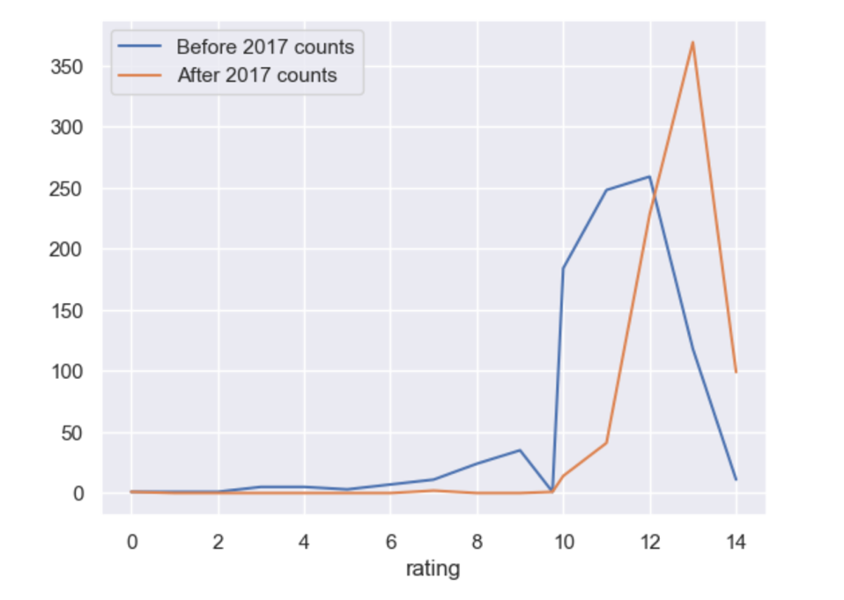

The above graph bores this out to some degree. Above are the counts of each rating for the periods split before and after 2017. We can see that prior to 2017 (the blue line) ratings that were < 10 did not seem that uncommon. And ratings less than 12 made up the majority of the ratings. After 2017, however, all that changes. We see almost no ratings that fall below 10, and relatively fewer that fall below 12.

Taken together these findings suggest that there was a general trend upwards in the ratings of the good boys, but that the upward trend was accompanied by a reduction in the number of bad boy ratings. So maybe these results don’t actually show that the good boys are getting better? It might just be that the bad boys are catching up.